**Running the Bitcoin Simulator – Sending Transactions**

**Introduction**

First form a group amongst yourself.

On the simulator page, start by creating a wallet. After that select generate a new wallet by keying in a unique name. This is an individual wallet.

Each group will create its own blockchain with a unique name. Click on” Switch” on the Simulator page. One person will key in a unique Blockchain name.

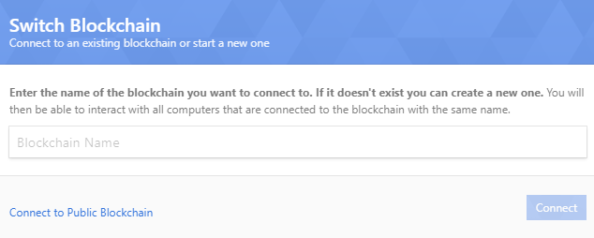

Each member will key in the same blockchain name. Select the hash difficulty function with 2 zeros (more zeros will take more time). Also select a small block reward.

Note: If you are doing this alone to simulate other miners you have to use multiple browsers.

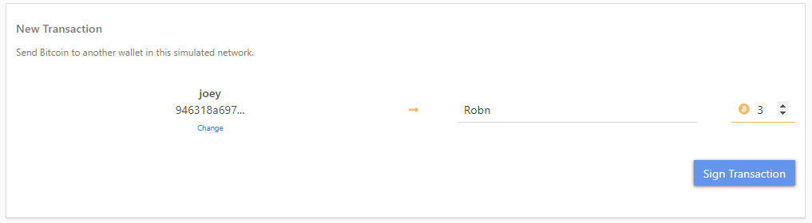

After signing it goes into the **mempool**. Each miner should have the same transactions in the mempool.

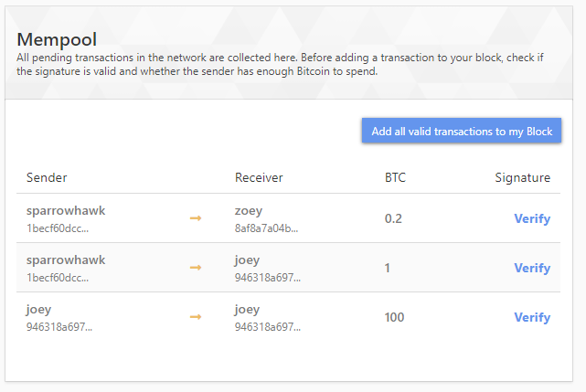

Click verify at the mempool and add to the block. More than 1 transaction can be added to the current block. However, only valid transactions (i.e. signed correctly and with sufficient balance) can be added to the current block.

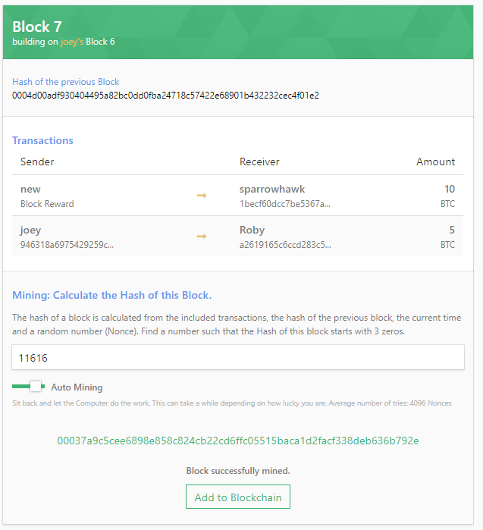

To add to this block to the blockchain you have to mine it first. Use auto mining. Multiple miners can mine their own block with **different** transactions. However, only the block created by the **winner** of the Proof of Work miner can be added to the blockchain. Unsuccessful transactions will drop back to the **mempool**. Verify all miners’ have the same blockchain.

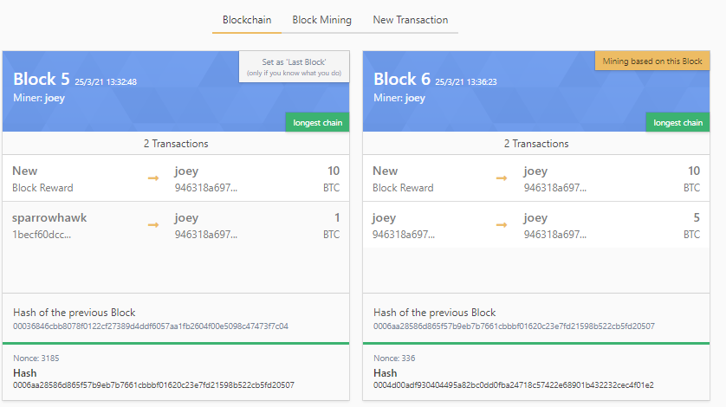

**Exercise**

Do all these:

1. Create a transaction with invalid signature
2. Create a transaction with insufficient balance but mine it anyway. What happens?
3. Create a transaction from A to B; observe the mempool in other miners, select one of the miners to mine.
4. Create a transaction say, A to B but have it mined by C, D, E at the same time with the same transactions
5. Create a few transactions but have it mined by C, D, E at the same time with different selected transactions from mempool.
6. Create a transaction A to B, have it mined, but one of the miners say C do not add it to the blockchain. Now create another transaction and have it mined. What happens to the C’s blockchain?
7. Create a double spending transaction – List down how you would do it.

**For Submission as Group.**

Include the names of everyone in the submission.

List down the steps you will need to create a double spending on the Simulator. Be as clear and concise as possible.

Include images to show

1. The initial balance of those involved
2. The transaction used to create double spending.
3. the final blockchain.